Experiment 1 Various simulated signal source experiments
Experimental content
1．Testing the waveforms of the various analog signals.
2．Measure the waveform of the signal tone signal.
One、Experimental objective ：
  - Familiar with the generation methods of various analog signals and their use
  - Observe and analyze the characteristics of various simulated signal waveforms.
Two、Circuit working principle
The analog signal source circuit is used to generate various audio signals required for the experiment: synchronous sine wave signal, asynchronous sine wave signal, voice signal, music signal, etc.
（One）Synchronous signal source (synchronous sine wave generator)
1．Function
The synchronous signal source is used to generate a 2 KHz or 1 KHz sine wave signal synchronized with the encoded digital signal as an input audio signal for the incremental modulated encoding, PCM encoding experiment. In the absence of a digital storage oscilloscope, it is used as the input signal of the encoding experiment, and a stable encoded digital waveform of the signal can be observed on the ordinary oscilloscope.
- Circuitous philosophy
Figure 1-1 shows the circuit diagram of the synchronous sine signal generator. It consists of 2 KHz (or 1 KHz) square wave signal generator (omitted in the figure), high-pass filter, low-pass filter and output circuit.P2 figure 1-1
The 2 KHz (or 1 KHz) square wave signal is programmed by a logic circuit within the CPLD programmable device U101. And TP 104 is the point of its measurement. U107C and its surrounding resistance network form a second-order high-pass filter with a cut-off frequency of ω L to filter out each harmonic. The resistance and surrounding U107D form a second-order low-pass filter with a cut-off frequency of ω H to filter out the clutter below the base wave. The bandpass filter of a 2 KHz (or 1 KHz) sine wave outputs only a 2 KHz (or 1 KHz) sine wave, with TP 107 as its measurement point. The output circuit is composed of BG 102 and peripheral resistance element, which plays the role of impedance matching, isolation and improving driving ability.
W104 was used to change the magnitude of the feedback amount of the high-pass filter so that it works in a steady state, and W105 was used to change the amplitude of the output sine wave.
（Two）Unsynchronous signal source (unsynchronous sine wave generator)
1．Function
The asynchronous signal source is a simple sine wave signal generator, which can produce sine wave signal with frequency of 0.3 ~ 10 KHz (using range 0.3~3.4KHz) and output amplitude of 0~2V. It can be used to qualitatively observe the frequency characteristics of the communication circuit and simultaneously serve as an audio signal source for incremental modulation, pulse-encoded modulation experiments.
- Operational principle
The circuit diagram of the asynchronous signal source is shown in P3 Figure 1-2. It consists of a sine-wave oscillator and a first-order output circuit. The sine wave oscillator consists of U107A, U107B and R and C elements. R103 and C101 are the feedback elements. Adjusting W101 and W102 can change their oscillation frequency between 0.3~3.4KHz. Adjusting W103 allows the output (measured at TP 108) to vary between 0 and 2 V. The output circuit is composed of BG 101 and RC element, which is a primary electrode follower, which plays the role of isolation, impedance matching and improving driving ability.

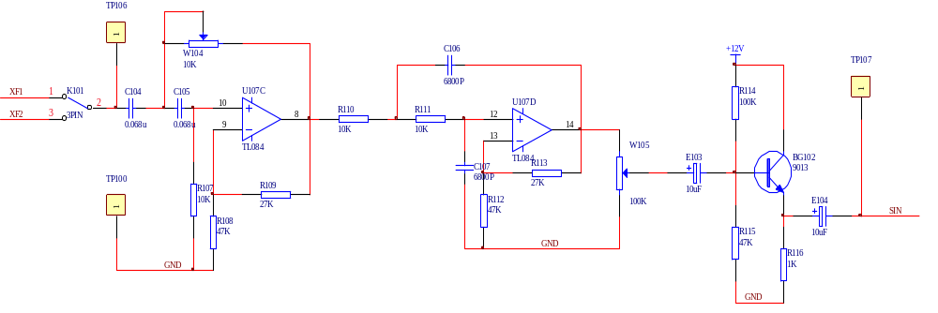

Figure1-1 Circuit diagram of the synchronous sinusoidal signal generator

（Three）Microphone input circuit (microphone circuit)
1．Function：
The microphone circuit is used to provide the DC operating voltage to the electret microphone.
- Theory：
As shown in FIG. 1-3, the VCC provides about 2.5V working voltage to the microphone, and the voltage on the microphone and R101 changes during speaking, and the voltage change component is the voice signal, which is coupled by E101 and sent to the analog signal input and selection electronic switch.
（Four）Musical signal generation circuit
1．Function
The music signal generating circuit is used to generate music signals and send them to the audio terminal circuit to check the opening of the voice channel and the call quality.
- Operational principle
See Figure 1-4 for the music signal generating circuit. The music signal is generated by the U109 music piece thick film integrated circuit. The 1 foot of the piece is the power end, 2 feet is the control end, 3 is the output end, and 4 is the public end. VCC provides 3.3V power supply voltage to U109 through 1 foot through R117 and D101. When the 2 feet input the control voltage + 3.3V through K105, the music signal is output from the third foot and is sent to the analog signal input selection electronic switch through E105.
（Five）Plus an analog signal input circuit
In some special cases, the simple sine wave signal generator can not meet the requirements of the experiment, so it is necessary to use the external signal source to provide the required signal. For example, to quantitatively test the characteristics of the frequency of the communication circuit, it is necessary to use audio test signals with a very stable frequency range of frequency and level and output impedance, which requires external audio signal generator or function signal generator. The additional analog signal input circuit provides them with an interface circuit connected to the experiment.
(Six) Analog telephone input circuit
Figure 1-5 is a telephone input circuit composed of PBL38710 / 1 telephone integrated circuit. J103 is the transmitter interface of the handle. The voice signal is input from TIPX and RINGX pins and output from VTX and RSN pins after U112. The output signal is divided into two ways, one is sent to PCM (1) of K103 or to PCM (2) encoder 2-3 of K103; the other is sent to 1-2 or 2-3 of K104 to receive the J105, and then selects the speaker of the sound signal output circuit.

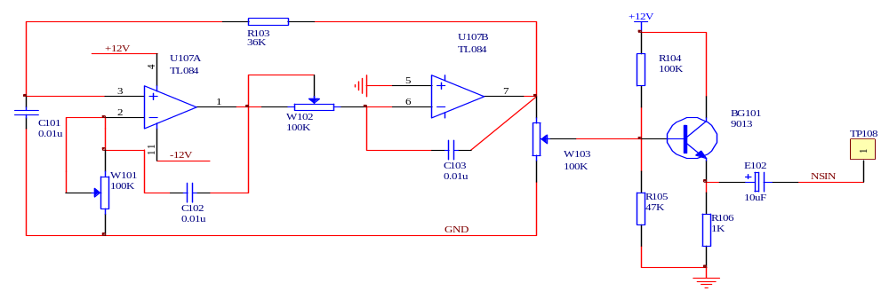

Figure 1-2 Circuit diagram of unsynchronous sine wave signal generator

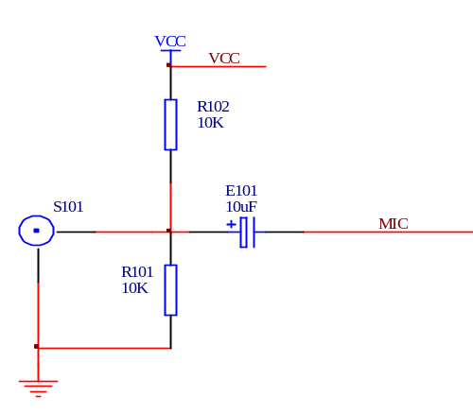

Send the analog signal input selection switch

Figure 1-3 Send the analog signal input selection switch

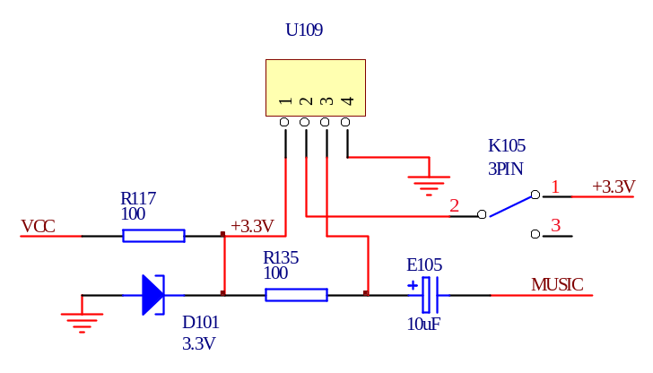

Send the analog signal input selection switch

Figure1-4 Circuit diagram for generating music signals

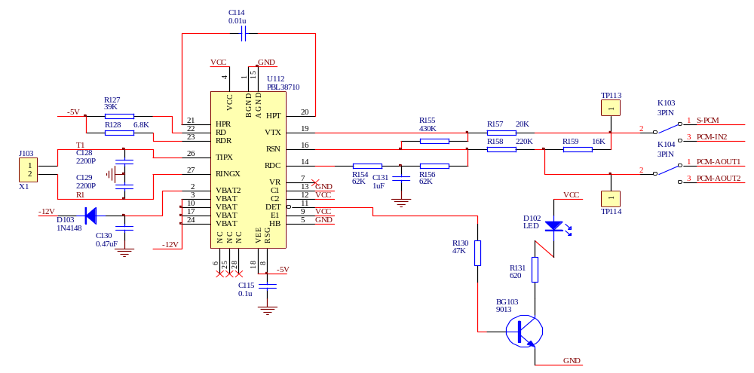

Figure1-5 Schematic of telephone input
Three、 Experiment content
1．Measure the waveform of each point at the corresponding test point: synchronous signal source, non-synchronous signal source, telephone input circuit, voice input circuit, and external analog signal input circuit.
2．Be familiar with the generation method, source and place of the above various signals, and understand the signal process.
Four、 Experimental procedure
1．Measure the point waveforms of TP 106, TP 107, TP 108, TP 109, TP 110, TP 112, TP 113, TP 114.(K101 is connected to 2-3)
2．When measuring the music signal, use K105 to turn on + 3.3V, and make the music piece add the control signal to produce the music signal output.
Five、Waveform of each measurement point (experimental results)
TP106：2 KHz or 1 KHz square wave, because the element parameters of the active low-pass filter are dominated by 2 KHz.
Therefore, 2 KHz sine wave is used for normal operation, and when normal, K101 is set at 2-3. The filtering effect of 1 KHz signal is worse, so the effect of 1 KHz output waveform is not very ideal.(To draw)
TP107：A 2 KHz or 1 KHz sine wave signal output synchronously with the working clock.(To draw)
TP108：The sine wave of the 0.3~3.4KHz.(To draw)
TP109：The channel terminal receives the analog signal input.
TP110：Audio power amplifier input signal.
TP111：Audio output signal.
TP112：The communication circuit terminal sends the analog signal output.
TP113：Telephone signal of the telephone circuit to the PCM encoder.
TP114：The telephone circuit sends to the voice terminal to receive the voice signal of the filter circuit.
TP104：Don't draw.
TP105：Don't draw.

